Configuration MVN for API testing

Configure MVN

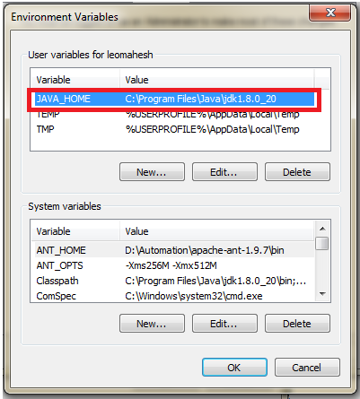

After install MVN form Eclipse or manually you need to copy the path of MVN and pest into class path under the environment variable

C:\Program Files\apache-maven-3.3.9\bin;

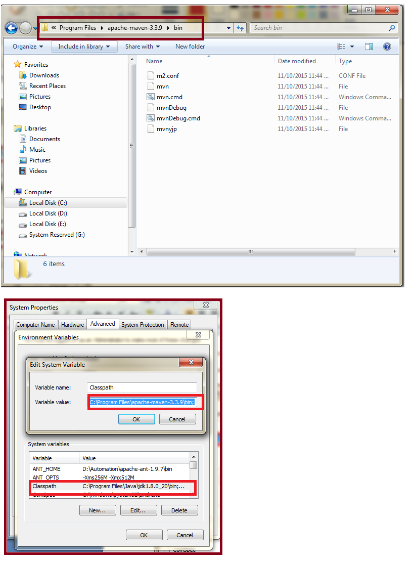

Open command prompt and check whether your maven is configured or not

MVN –version

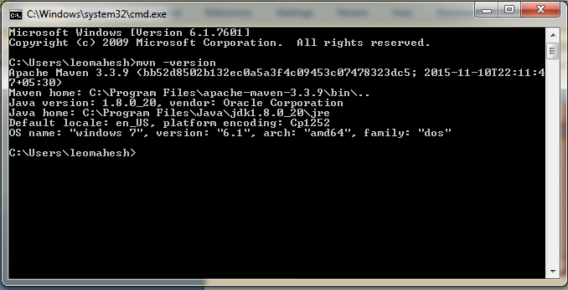

Open Eclipse with new workplace for API testing if you use your old one no problem I am just use for demo purpose

Once your eclipse open go on the below path

https://www.youtube.com/watch?v=DP9awGiMKZQ&list=PLmfZ8pjwM0vTVzGG5v0CrWxJaeHPP1KvH&index=18

File –New-Other-Maven

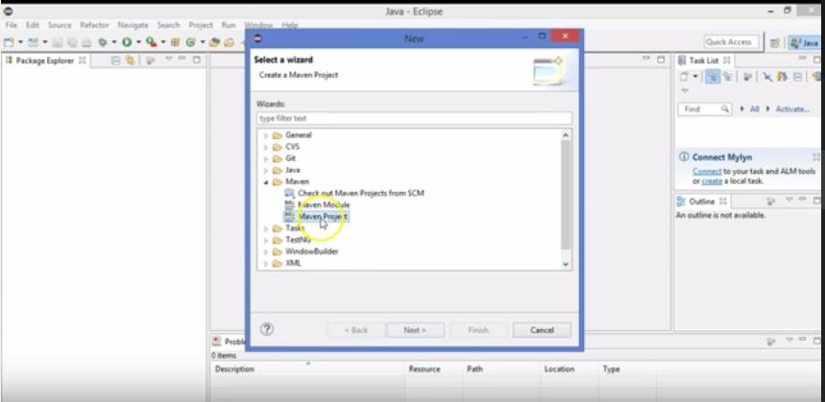

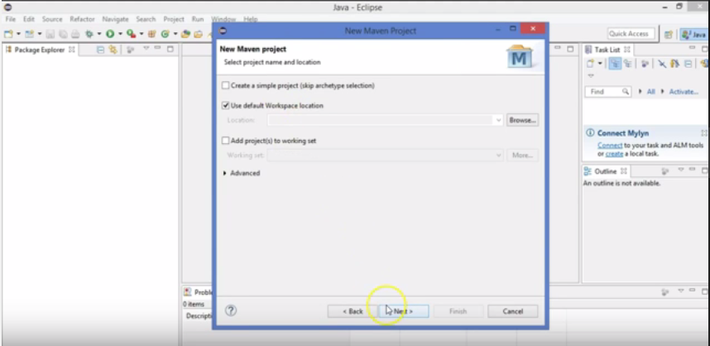

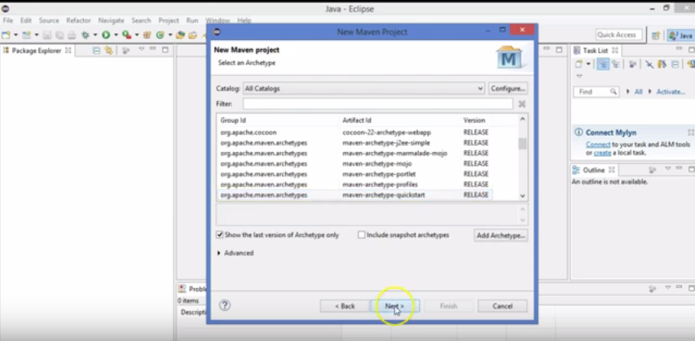

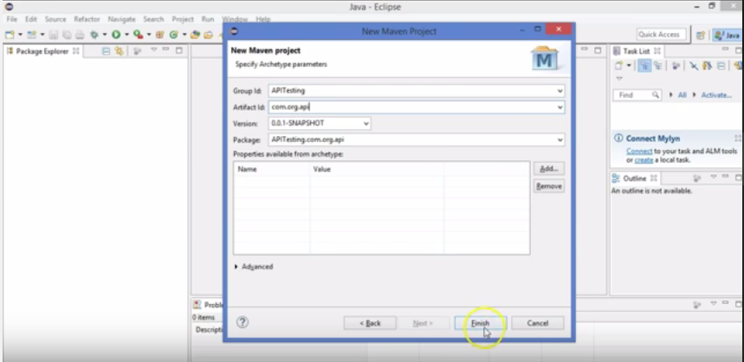

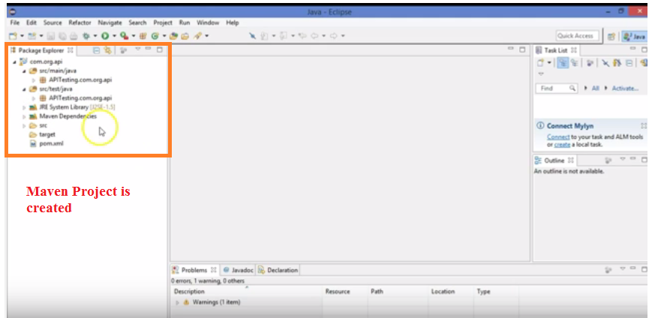

Downloading PreREquisites to start Automation

Open the pom.xml files

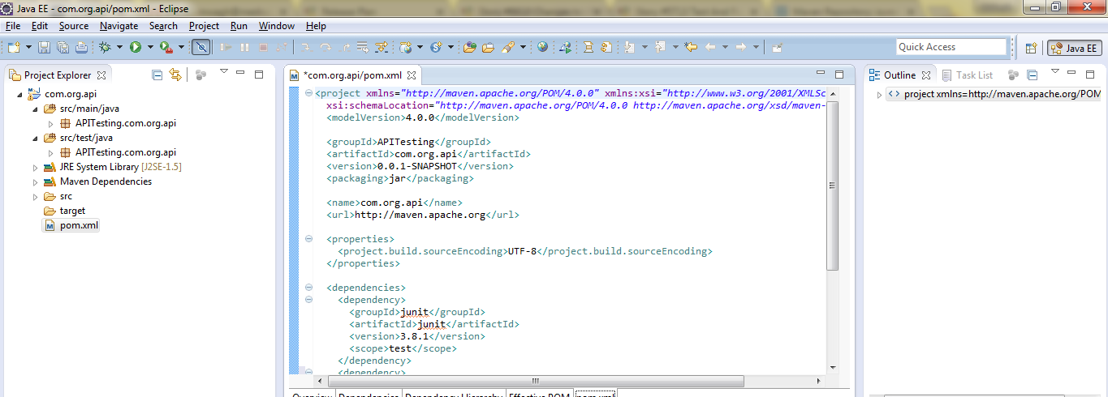

You need some Jar file that we now going to configure goto

<https://mvnrepository.com/>

Type TestNG and configure it in your pom.xml copy the dependency

We need TestNG fro to run group wise test case or run particular test case in your application with the help of TestNG you can do it.

When we want to sent JSON request for this **REST Assured** (JAR) library is developed

Next we need **Json Path**

Next we need **Json Schema Validator**

**Json Schema Validator » 2.2.0**